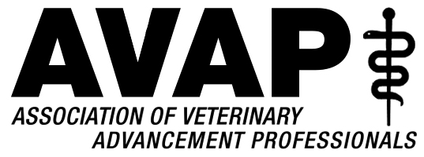
Danielle Johnson, President  Ohio State University  Joe Montgomery, Vice President/President Elect  Kansas State University  Gretchen Morgan, Immediate Past President  Louisiana State University | Bill Venne, Secretary  University of Minnesota  Lynne Haley, Treasurer  Washington State University  Karen Johnson, Treasurer Elect  University of Florida | Julie Byczynski, Member at Large  University of Guelph Ontario  Chastity Carrigan, Member at Large  Texas A&M University  Alison Davitt, Conference Planner  Virginia-Maryland

March 18, 2019
Dr. Emily Cross
Nestle Purina Pet Nutrition Inc.
emily.cross@purina.nestle.com

Dear Dr. Cross,

Thanks to you and to Nestle Purina Pet Nutrition for your continuing sponsorship of our Association of Veterinary Advancement Professionals Annual Conference.

This letter accompanies an official request for support for our 2019 Annual Conference, which will be held in Washington, D.C.

The Association of Veterinary Advancement Professionals is an organization of development, public relations and alumni relations professionals that seeks to promote the success of veterinary medical education through the professional development of its membership. Our annual conference attracts 100+ attendees from veterinary colleges across North America and Canada.

Again heartfelt thanks to you and to Nestle Purina for your generous support of our program. It makes incredible things possible.

Sincerely,
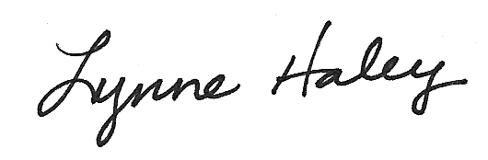
Lynne Haley, Senior Director
Veterinary Development and Alumni Relations
Washington State University College of Veterinary Medicine
Treasurer, Association of Veterinary Advancement Professionals

