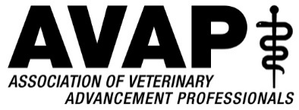

Monthly Conference Call Minutes
January 13, 2020
Phone: 1-877-820-7831 (Code: 824636#)
- 2020 Conference-
  - Program ideas and discussion –
Cheryl looks for consistent ideas and top issues and crafted a draft conference agenda with ideas and topics. They are now placeholders waiting to be refined. Discussion about AAAVMC Awards, sessions, speakers and content are shaping up. Discussion about which tracks, topics and how many breakouts to have. A lot of time spent on narrowing and combining topics, engagement with speakers and sponsors. Corporate people could share what they are looking for with engagement in Vet Schools now. They are working hard on a spreadsheet of all the topics, speakers and how to plug them into a schedule.

- Task Force Update/Survey from Cheryl-
AVAP Conference Planning Task Force Summary of Activities and Findings: January 2020
Executive Committee looking at findings, we will evaluate and decide on recommendations for changes, possibly bring to the greater group at AVAP 2020 to vote on or discuss recommendations. A full discussion is tabled for next time after it is fully reviewed by all.

- Other business-
Next meeting may be moved due to WVC.

Attending- Joe, Julie, Karen, Danielle, Bill, Kay, Cheryl, Chastity, Gretchen, Tim

